**Create the K8s EKS,further you have to do the deployment of Nginx application**

1. **kubectl to deploy the application to an AWS EKS cluster**

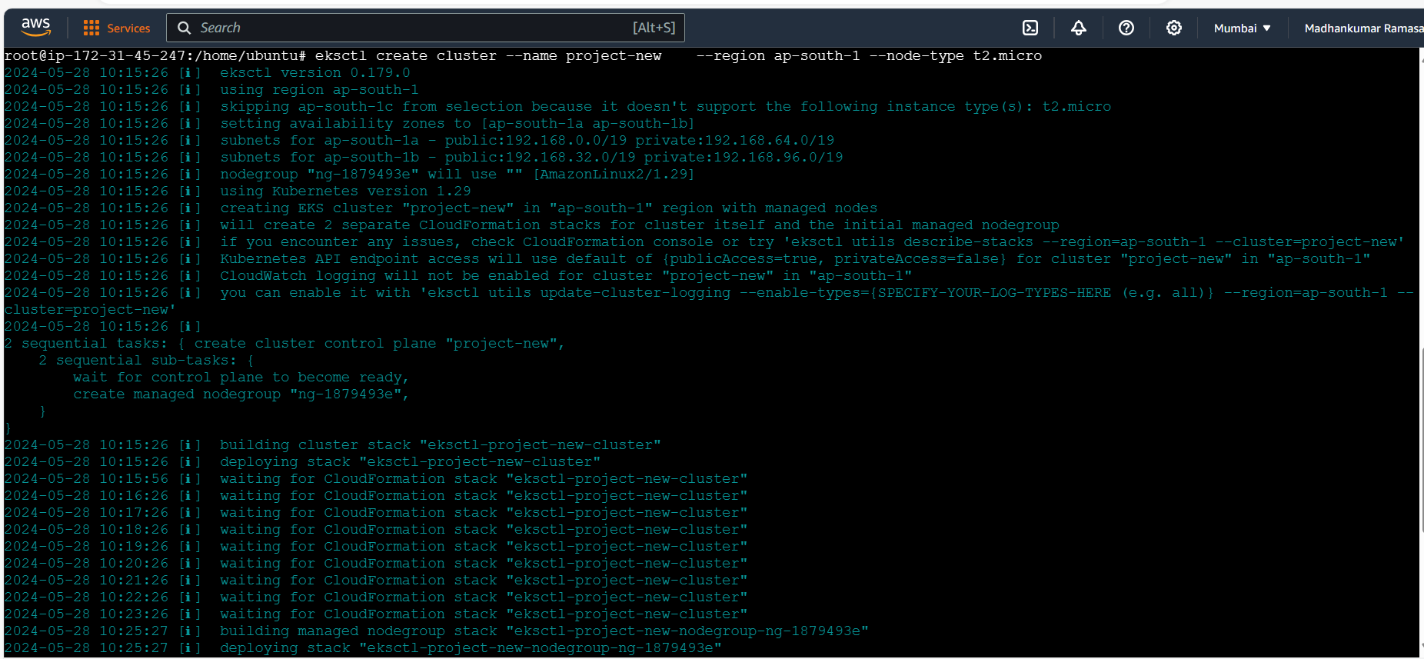

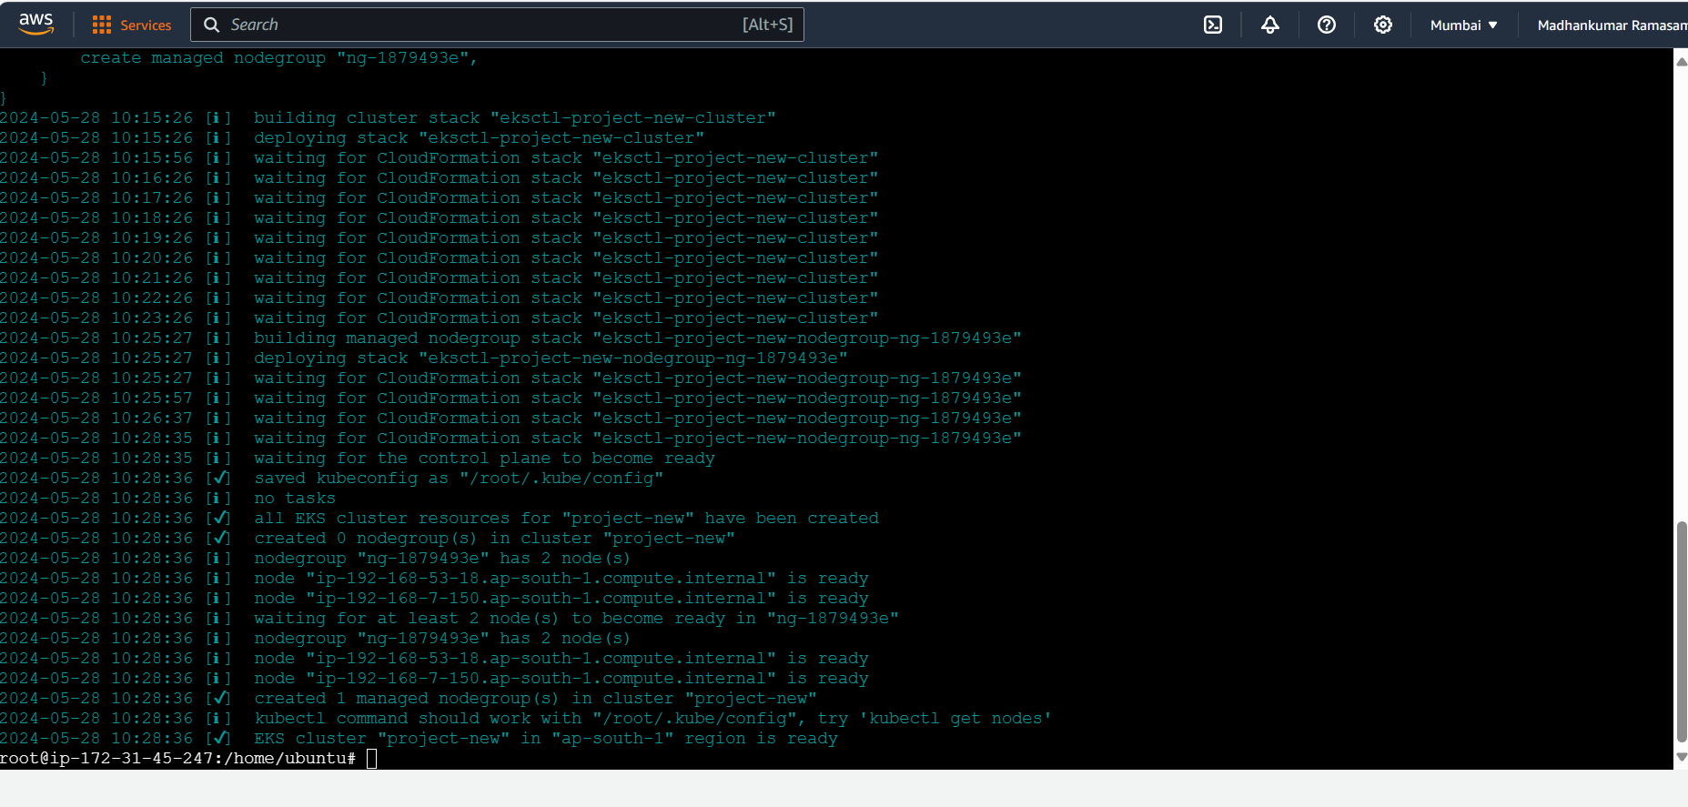

1. **get kubectl nodes**



1. **Deploy the Nginx application**

